ZYKL — Rencana Peluncuran Social Media 4 Minggu
Sep 29, 2026 · @vvv

Langsung jualan atau bertahap?
Bertahap. Akun dengan nol follower yang langsung posting "Download now" terasa seperti iklan yang tidak diminta; post yang sama setelah tiga minggu konten yang berguna dan enak dilihat terasa seperti langkah yang wajar. Rencana ini punya empat fase, satu fase per minggu, dan Play Store baru disebut di fase 3.
Minggu | Fase | Yang ingin dirasakan audiens | Seberapa banyak produk | Ajakan (CTA)
1 | Pemanasan: masalahnya | "Itu HP aku banget." | Tidak ada — hanya ide | Save, share, balas
2 | Reveal: di balik layar | "Ada yang bikin alat tenang untuk ini." | Sekilas: dial, kertas, vinyl | Follow untuk peluncuran
3 | Launch: kenalan dengan ZYKL | "Bagus banget, dan gratis." | Penuh: video, fitur | Link di bio, sekali per post
4 | Bukti: rutinitas & komunitas | "Orang seperti aku beneran pakai." | Dipakai dalam rutinitas nyata | Coba, ceritakan setup-mu
Tiga aturan berlaku selama empat minggu:
- 80/20 — minimal 4 dari 5 post memberi sesuatu (ide, tips, visual yang indah) sebelum meminta apa pun.
- Satu ajakan per post — save, balas, atau download; jangan ketiganya sekaligus.
- Isi dulu sebelum mengundang — publikasikan 3 post Instagram pertama sekaligus di hari pertama, supaya pengunjung pertama melihat grid yang sudah hidup, bukan satu post sendirian.

Gaya bicara dan pilar konten
ZYKL bicara seperti pembuat yang berpikir matang, bukan seperti brand: tenang, presisi, sedikit kering, tidak pernah hype. Kalimat pendek, huruf kecil boleh di Threads, tanpa tanda seru, tanpa tumpukan emoji, tanpa kata "game-changer".
Pilar | Porsi post | Isinya | Contoh hook (bahasa Inggris)
Attention (perhatian) | 30% | HP, notifikasi, fokus, cemas karena to-do list | "Your phone has 38 things to tell you. None of them are your work."
Less, but better | 25% | Filosofi desain, Dieter Rams, material, suara | "Why a timer should look like an instrument, not an app."
The instrument (produk) | 25% | Dial, dispenser, vinyl, lockdown, edisi | "Five tasks. That's the whole list."
Honest ownership | 10% | Inti gratis, tanpa iklan, tanpa akun, offline | "No account. No cloud. Your data never leaves the phone."
Rituals (rutinitas) | 10% | Meja kerja nyata, rutinitas, setup pengguna | "A 4-cycle morning, start to finish."
Kata yang dipakai: quiet, instrument, intent, cycle, desk, ritual. Kata yang dihindari: productivity hack, grind, 10x, crush it, revolutionary.

Profil dan bio
Pakai logo berbentuk jam (ZYKL_Avatar_Clock_dark_1080) sebagai foto profil Instagram dan Threads ZYKL, bukan logo teks saja. Alasannya: di ukuran 110 px bentuk jam langsung terbaca, sedangkan huruf "ZYKL" jadi kecil; bentuk jam juga sama dengan ikon app di Play Store, jadi orang yang melihat profil lalu membuka toko mengenalinya sebagai produk yang sama. Nama "ZYKL" sudah tampil di nama akun, jadi tidak perlu diulang besar-besar di foto.
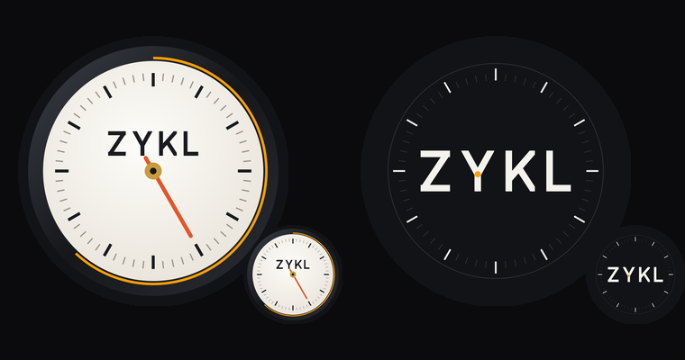
Kolom | Isi yang disarankan
Name (Instagram) | ZYKL | Pomodoro Focus Timer — kolom nama ikut dicari di Instagram, jadi kata kuncinya membantu
Username | zykl.app
Category | App page
Link | Minggu 1–2: zykl.app · mulai minggu 3: link Google Play
Bio Instagram (maks. 150 karakter), ganti saat peluncuran:
Minggu 1–2 (106 karakter):
Quiet time. Physical intent.
An analog pomodoro instrument for Android.
Launching soon. Follow the build ↓
Mulai minggu 3 (123 karakter):
Quiet time. Physical intent.
Analog pomodoro timer · 5-task list · vinyl focus sounds
Free on Android. No ads, no account ↓
Bio Threads ZYKL:
Minggu 1–2 (100 karakter):
Building a quiet focus instrument for Android. Less, but better. Let's talk focus, desks and design.
Mulai minggu 3 (112 karakter):
A quiet pomodoro instrument for Android. Less, but better. Free, no ads, no account. Let's talk focus and desks.
Bio untuk akun pribadimu ada di tab Threads pribadi. Satu catatan: ikon app di Play Store saat ini masih memakai huruf lama; kalau nanti diperbarui dengan wordmark baru, logo jam ini bisa langsung dijadikan ikon app supaya semuanya seragam.

Instagram dan Facebook: 12 post berurutan
Posting tiga kali seminggu (Senin, Rabu, Jumat) plus satu Story setiap hari. Grid berselang-seling Obsidian (gelap) dan Warm Bone (terang), jadi profil terlihat sebagai satu objek yang tenang dan terdesain. Facebook memakai post yang sama di hari yang sama dengan dua perbedaan: maksimal dua hashtag, dan mulai minggu 3 link Play Store langsung ditaruh di post karena link di Facebook bisa diklik.
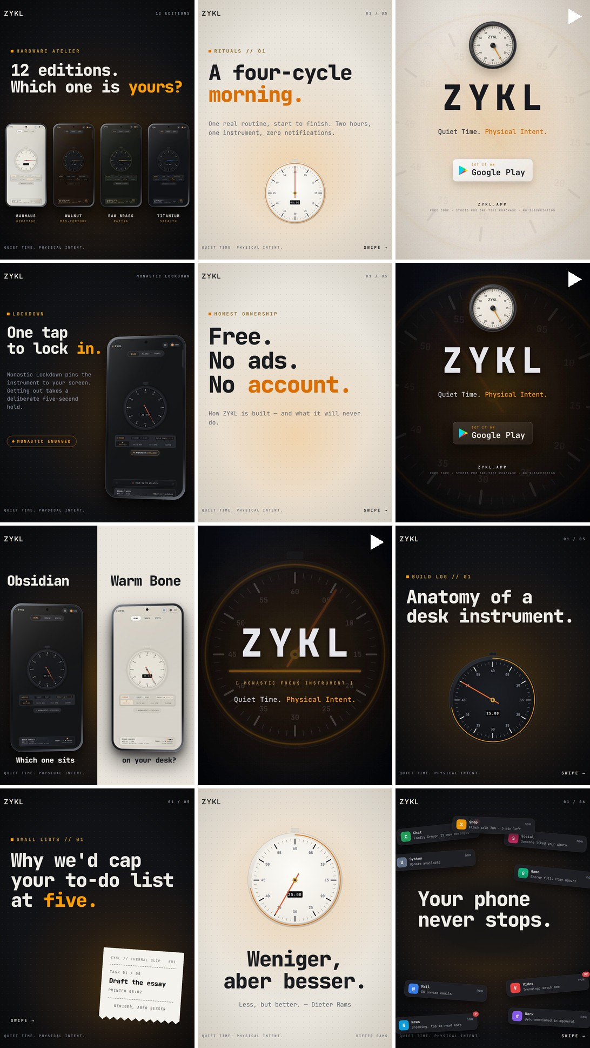
# | Hari | Format | Folder aset | Hook
1 | M1 Sen | Carousel, 6 slide | W1-01 Your phone never stops | Your phone never stops.
2 | M1 Sen (isi awal) | Single, terang | W1-02 Weniger aber besser | Less, but better.
3 | M1 Sen (isi awal) | Carousel, 5 slide | W1-03 Why five | Why we'd cap your to-do list at five.
4 | M2 Sen | Carousel, 5 slide | W2-01 Anatomy | Anatomy of a desk instrument. (nama ZYKL muncul)
5 | M2 Rab | Reel, 12 detik | Reel_W2_Teaser_12s_9x16.mp4 | What if it could stop?
6 | M2 Jum | Single, split | W2-03 Obsidian or Warm Bone | Which one sits on your desk?
7 | M3 Sen | Reel, 40 detik | ZYKL_Promo_Motion_40s_EN_9x16_v2.mp4 | ZYKL is here. (peluncuran)
8 | M3 Rab | Carousel, 5 slide | W3-02 Honest ownership | Free. No ads. No account.
9 | M3 Jum | Single | W3-03 Lockdown | One tap to lock in.
10 | M4 Sen | Reel, 40 detik | ZYKL_Promo_Motion_40s_EN_Light_9x16.mp4 | Same quiet, in daylight.
11 | M4 Rab | Carousel, 5 slide | W4-02 Four-cycle morning | A four-cycle morning.
12 | M4 Jum | Single | W4-03 Editions | 12 editions. Which one is yours?

Caption siap tempel (bahasa Inggris, untuk akun ZYKL)
1 · Your phone never stops Your phone never stops. It buzzes, lights up and asks for one more second — dozens of times a day. We've been thinking about what that does to real work, and what a calmer desk could look like. Swipe through, and save it for the next time your screen won't leave you alone. #deepwork #focus #digitalminimalism #pomodoro #desksetup
2 · Weniger, aber besser Weniger, aber besser. Less, but better. Dieter Rams said it about radios and record players. We think it fits the tools on your desk today — the one in your pocket most of all. What's one thing you'd remove from your workday? #dieterrams #lessbutbetter #industrialdesign #minimalism #focus
3 · Why five Long lists feel organized. Mostly they create guilt. Five slots force one honest question: what actually matters today? How many items are on your list right now? Reply with the number. #todolist #deepwork #intentionalliving #focus #productivity
4 · Anatomy of a desk instrument Build log 01. For months we've been making ZYKL — a focus tool for Android that behaves less like an app and more like an object on your desk. Three units: an analog chronometer, a thermal task dispenser and a 33⅓ RPM turntable. Launching soon. Turn on post notifications to be first. #buildinpublic #androidapp #pomodoro #industrialdesign #desksetup
5 · Teaser reel Your phone never stops. What if it could? Sound on. #focus #deepwork #androidapp #motiondesign
6 · Obsidian or Warm Bone Same instrument, two finishes: one for late nights, one for bright mornings. Which would sit on your desk? Comment O or W. #desksetup #minimalsetup #industrialdesign #darkmode
7 · Launch reel ZYKL is here. A quiet focus instrument for Android: an analog chronometer, a five-task thermal dispenser, a turntable with twenty offline soundscapes and a one-tap Lockdown. Free to download. No ads, no account, no subscription. Link in bio. #zykl #androidapp #pomodoro #focus #deepwork
8 · Honest ownership Free. No ads. No account. That isn't a launch promo — it's how ZYKL is built. Your tasks and focus history never leave your phone. The core stays free; Studio PRO is one purchase if you want every edition and soundscape. #privacy #offlinefirst #nosubscription #androidapp #digitalminimalism
9 · Lockdown One tap to lock in. Monastic Lockdown pins ZYKL to your screen so the phone stays a timer, not a temptation. Getting out takes a deliberate five-second hold. Would you use it? #focusmode #deepwork #pomodoro #androidapp
10 · Light reel The Warm Bone edition: the same quiet, in daylight. Dark or light — which do you prefer? #desksetup #minimalism #industrialdesign #zykl
11 · A four-cycle morning Five tasks printed, a record on, four rounds of 25/5, two stamps. That's the whole morning. What's your focus ritual? Share it and tag us — we'll feature a few setups next week. #morningroutine #deepwork #pomodoro #studywithme #desksetup
12 · Editions Twelve hardware editions, from Bauhaus to raw brass. Some are free; the full set comes with Studio PRO. Which one is on your desk? #industrialdesign #bauhaus #desksetup #minimalism #zykl

Story, satu per hari
- Minggu 1–2: poll atau slider tentang post hari itu ("How many unread notifications right now?"), foto meja kerja, klip 5 detik dial yang berdetak.
- Minggu 3–4: repost setiap mention, link sticker ke Google Play dua kali seminggu, question box ("What should edition 13 be?").
- Mulai minggu 3, pasang tiga Highlight: Start here, Build log, Your desks.

Bonus #13 · One instrument, many rituals
Carousel 7 slide (Warm Bone, folder W4-EXTRA Many rituals) yang menunjukkan ZYKL juga dipakai untuk membaca, belajar, deep work, menulis, dan latihan. Pasang di minggu 4 hari Sabtu atau awal minggu 5.
13 · Many rituals One instrument. Many rituals. ZYKL started as a work timer, but the dial doesn't care what you're focusing on: a chapter of a book, a problem set, a first draft, twenty minutes of scales. What would you use it for? #reading #studywithme #deepwork #pomodoro #focus

Jangan selalu gambar: video asli
Mulai minggu 2, ganti satu post gambar per minggu dengan video asli 7–20 detik (Reels + Threads). Rekam dengan mode Jangan Ganggu menyala, HP ZYKL di stand, direkam dari HP kedua dengan cahaya alami, dan pakai suara asli (detak dial, kertas, vinyl) — suara-suara ini adalah kekuatan ZYKL.
Video | Yang direkam | Durasi | Caption (EN)
Reading with ZYKL | Dari atas: buku terbuka, HP di stand dengan dial berjalan dan soundscape Library; tangan membalik halaman; close-up stempel [DONE] pada "Read chapter 4" | 15 dtk | One cycle, one chapter. Sound on.
25-minute timelapse | Meja dari satu sudut, 25 menit dipercepat jadi 10 detik, berakhir saat dial mencapai nol | 10 dtk | 25 minutes in 10 seconds. What did you finish in your last cycle?
Stamp ASMR | Rekaman layar + suara asli saat print task dan stempel [DONE] | 8 dtk | The most satisfying button we've ever made.
Needle drop | Rekaman layar memilih record, jarum turun, suara dari speaker | 12 dtk | Put a record on before you start.
Lockdown, for real | Tangan tap Monastic Lockdown, taruh HP di stand, lanjut membaca | 10 dtk | One tap. Then the phone is just a clock.
Morning desk | Pan pelan meja dengan edisi Warm Bone di cahaya pagi | 12 dtk | Warm Bone, 7 a.m.
Urutan yang disarankan: "Morning desk" di minggu 2, "Stamp ASMR" di minggu 3, "Reading with ZYKL" di minggu 4, lalu sisanya di minggu 5 dan seterusnya.

Seri "Rituals": satu foto realistis per kegiatan
Carousel #13 memperkenalkan idenya; seri ini memperdalamnya dengan satu post per kegiatan, masing-masing foto asli meja dengan ZYKL di sampingnya. Jalankan satu post per minggu mulai minggu 5 (atau tiap Sabtu), bergantian antara edisi Obsidian dan Warm Bone.
Fotonya sebaiknya foto asli yang kamu ambil sendiri, bukan gambar buatan AI: gambar AI lama menunjukkan kenapa — HP-nya jadi iPhone dan tulisan di layar rusak — dan pengguna bisa merasakan bedanya. Foto asli juga otomatis menampilkan UI yang benar karena ZYKL-nya memang menyala di HP.
Aturan foto untuk semua kegiatan:
- Format vertikal 4:5, cahaya jendela dari samping, tanpa flash.
- HP di stand, kecerahan layar tinggi, mode Jangan Ganggu menyala, layar sedikit menghadap kamera.
- Satu properti utama per foto; meja rapi; warna hangat dan kalem (kayu, kertas, linen).
- Ambil 3 variasi per kegiatan: lebar (seluruh meja), sedang (properti + HP), dekat (tangan sedang beraktivitas, HP blur di belakang).
- Kirim fotonya ke saya; saya tambahkan label kecil dan wordmark supaya seragam dengan grid.
Kegiatan | Yang ada di foto | Layar ZYKL | Label di foto
Membaca | Buku terbuka, pembatas buku, secangkir teh | Turntable memutar soundscape Library | FOR READING
Belajar | Buku catatan, stabilo, laptop tertutup | Dispenser berisi 5 task belajar, satu sudah di-stempel | FOR STUDYING
Ngoding | Laptop dengan editor kode, headphone | Dial berjalan + Monastic Lockdown menyala | FOR DEEP WORK
Menulis | Jurnal dan pulpen, halaman setengah terisi | Dial di tengah siklus | FOR WRITING
Latihan musik | Gitar atau keyboard kecil, buku lagu | Dial siklus pendek (15/3 atau custom) | FOR PRACTICE
Belajar bahasa | Kartu kosakata, kamus kecil | Dispenser: "20 new words", "1 podcast episode" | FOR LANGUAGES

Caption per kegiatan
Membaca
- Instagram (EN): One cycle, one chapter. Tea on the left, the dial on the right, the phone finally quiet. What are you reading this week? #reading #booklover #readingtime #pomodoro #zykl
- Threads ZYKL (EN): one cycle, one chapter. what's on your nightstand right now?
- Threads pribadi (ID): target baca 2 buku bulan ini. caranya: tiap malam 2 siklus @zykl.app, soundscape library, HP diem di stand. lagi baca apa kalian?
Belajar
- Instagram (EN): Study in honest blocks. Five tasks for the session, one stamp at a time. No 40-item list, no guilt. #studywithme #studygram #studytips #pomodoro #zykl
- Threads ZYKL (EN): five tasks per study session. enough to finish, small enough to start. how do you plan yours?
- Threads pribadi (ID): buat yang lagi skripsian: jangan tulis "kerjain skripsi" di to-do. tulis 5 hal kecil. "baca 2 jurnal", "revisi bab 2 halaman 4". lebih gampang mulai.
Ngoding
- Instagram (EN): Ship one thing before lunch. Four cycles, one feature, and a phone that behaves like a clock. #deepwork #developer #codinglife #pomodoro #zykl
- Threads ZYKL (EN): four cycles, one feature. what are you shipping today?
- Threads pribadi (ID): cara aku ngoding tanpa kepikiran buka chat: nyalain lockdown di @zykl.app, 4 siklus, satu fitur. kalau belum kelar, besok lagi.
Menulis
- Instagram (EN): Write badly for 25 minutes. The first draft needs a timer, not a blank page. #writing #writingcommunity #journaling #pomodoro #zykl
- Threads ZYKL (EN): the blank page loses to a 25-minute timer. every time.
- Threads pribadi (ID): tips nulis yang paling ngefek buat aku: jangan nunggu mood. set 25 menit, tulis jelek aja dulu. ngedit itu urusan besok.
Latihan musik
- Instagram (EN): Practice, in cycles. Fifteen focused minutes of scales beat an hour of noodling. #guitarpractice #musicpractice #practicemakesprogress #pomodoro #zykl
- Threads ZYKL (EN): short focused rounds > one long distracted hour. agree?
- Threads pribadi (ID): latihan gitar 15 menit fokus ternyata lebih kerasa progresnya daripada sejam sambil buka HP. siapa yang relate?
Belajar bahasa
- Instagram (EN): Twenty words, one cycle. Languages are learned in small, stubborn rounds. #languagelearning #studywithme #polyglot #pomodoro #zykl
- Threads ZYKL (EN): what language are you learning right now? one word, go.
- Threads pribadi (ID): lagi belajar bahasa apa? aku lagi nyicil bahasa [bahasa], 1 siklus sehari, 20 kosakata. pelan tapi jalan.

Threads: 20 post, ditulis seperti manusia
Di Threads, akun ZYKL bicara sebagai pembuatnya, bukan sebagai brand: orang pertama, huruf kecil boleh, satu ide per post, dan kebanyakan post diakhiri pertanyaan. Nama produk baru disebut di minggu 2 dan link baru muncul di minggu 3. Posting lima hari seminggu (Senin–Jumat) dan luangkan 20 menit sehari untuk membalas post orang lain tentang fokus, belajar, Android, dan desain — di akun baru, balasan mendatangkan follower lebih banyak daripada post sendiri.
Aturan: satu topic tag per post (Productivity, Design, atau Android), tanpa daftar hashtag, dan link selalu di balasan pertama, bukan di post. Angka dalam [kurung] adalah placeholder: ganti dengan angka aslimu atau hapus kalimatnya.
Gambar khusus Threads akun ZYKL ada di folder Threads ZYKL (EN): gaya instrumen gelap yang sama dengan Instagram, tapi formatnya kartu obrolan — pertanyaan, pilihan A/B/C, spec sheet — bukan slide produk. Satu gambar per post, 1080 × 1350.
Post | File | Isi gambar
1 | THR-01 | Tumpukan notifikasi, "Count your notifications before 9 a.m."
2 | THR-02 | Struk to-do berisi 38 item, 5 teratas ditebalkan
4 | THR-04 | Dial + "Less, but better."
6 | THR-06 | Dial dengan callout teknis: 1 tick per detik, bounce, readout
7 | THR-07 | 5 slot terisi, slot ke-6 dicoret
8 | THR-08 | Screenshot dispenser + stempel [DONE] besar
9 | THR-09 | Pilihan A–D (Rain, Lo-fi, Classical, Silence) + piringan hitam
10 | THR-10 | Spec sheet: No ads, No account, No cloud, No trackers
11 | Reel 40 detik | Video promo gelap
13 | THR-13 | Tiga HP: A dial, B receipts, C vinyl
14 | THR-14 | Struk "what you pay": core free, tanpa langganan, PRO one-time
17 | THR-17 | Dial Obsidian vs Warm Bone untuk poll A/B
18 | THR-18 | Empat edisi + slot kosong "?" untuk edisi 13
Post 3, 5, 12, 15, 16, 19 dan 20 sengaja tanpa gambar: teks murni sering dapat balasan lebih banyak di Threads, dan post 15 memakai foto mejamu sendiri.
Post bonus Threads ZYKL (minggu 4 Sabtu, lampirkan THR-USES): what do you focus on, besides work? reading, studying, code, writing, practice — or something we haven't thought of?
Akun Threads pribadimu menjalankan rencana paralel dalam bahasa Indonesia campur Inggris untuk audiens lokal, sambil men-tag akun ZYKL: Threads pribadi (ID)

Minggu 1 — masalahnya, belum ada produk
- Mon — counted my notifications before 9am today: [number]. not one of them was about the thing i actually needed to do.
- Tue — unpopular opinion: most to-do apps make you less productive. a list of 38 things isn't a plan, it's a guilt archive. how long is yours right now?
- Wed — what's the longest you've worked this week without touching your phone? mine was [minutes] minutes. be honest.
- Thu — dieter rams: "less, but better." he was talking about radios and record players. feels more true about phones than anything he designed.
- Fri — if you could keep only five tasks for tomorrow, which would survive? surprisingly hard exercise. try it.

Minggu 2 — build in public
- Mon — building a pomodoro timer that looks like a 1970s desk clock instead of an app. the hand ticks once a second with a tiny bounce, like a real escapement. too nerdy or exactly right? (attach: THR-06)
- Tue — design question: should a task list let you add a sixth item? we're leaning hard no. five, then you finish or archive something first.
- Wed — made a task list that works like a receipt printer. adding a task prints a paper slip. finishing it slams a red [DONE] stamp on it. unreasonably satisfying. (attach: THR-08)
- Thu — what do you listen to when you need to focus? rain, lo-fi, classical, silence? we're putting a little vinyl player in the app and arguing about the tracklist.
- Fri — no ads, no account, no cloud — everything stays on the phone. do you actually care about offline-first, or is that just a developer thing?

Minggu 3 — peluncuran, tetap ngobrol
- Mon — it's out. ZYKL: a quiet focus instrument for android. analog dial, five-task receipt printer, vinyl soundscapes, one-tap lockdown. free, no ads, no account. would love blunt feedback. (attach: 40 s reel; Play Store link in the first reply)
- Tue — day-one numbers nobody asked for: [downloads] downloads, [bug count] bugs reported, [x] people asked for a light mode (it exists). thank you, genuinely.
- Wed — which would you try first: the ticking dial, the receipt task list, or the vinyl player?
- Thu — why no subscription? because a timer shouldn't charge you rent. the core is free for good. there's one optional upgrade and it's yours for life.
- Fri — show me your desk. the messier the better. i'll go first. (attach: your own desk photo, phone on a stand)

Minggu 4 — rutinitas dan komunitas
- Mon — my four-cycle morning: five tasks, one record (kyoto bamboo), four rounds of 25 minutes. [x] tasks stamped, zero social media. what does yours look like?
- Tue — poll: which finish helps you focus? Obsidian (dark) / Warm Bone (light) / depends on the hour
- Wed — what should edition 13 be? we have walnut, raw brass, bauhaus, titanium. wildest idea wins.
- Thu — shipped a small update because of your replies: [what changed]. keep them coming.
- Fri — one month in. thank you for the replies, the bug reports and the desk photos. what should we build next?

Ritme mingguan
Setiap minggu bentuknya sama: tiga post Instagram/Facebook, lima post Threads, satu Story per hari, dan 20 menit membalas. Mulai dengan slot malam (19.00–21.00 di zona waktu audiens utamamu), lalu geser setelah Instagram Insights menunjukkan kapan follower-mu online, biasanya setelah minggu 2.
Minggu | Sen | Sel | Rab | Kam | Jum | Akhir pekan
1 · Pemanasan | IG/FB #1 + isi awal #2, #3 · Threads 1 | Threads 2 | Threads 3 | Threads 4 | Threads 5 | Story saja
2 · Reveal | IG/FB #4 · Threads 6 | Threads 7 | IG/FB #5 reel · Threads 8 | Threads 9 | IG/FB #6 · Threads 10 | Story saja
3 · Launch | IG/FB #7 reel · Threads 11 | Threads 12 | IG/FB #8 · Threads 13 | Threads 14 | IG/FB #9 · Threads 15 | Balas semua komentar
4 · Bukti | IG/FB #10 reel · Threads 16 | Threads 17 | IG/FB #11 · Threads 18 | Threads 19 | IG/FB #12 · Threads 20 | Evaluasi angka
Senin minggu 1 adalah pengecualian: publikasikan post #1–#3 sekaligus supaya grid tidak kosong, lalu bagikan #2 dan #3 ke Story di hari Rabu dan Jumat.

Kesalahan di gambar lama, dan penggantinya
Gambar buatan AI (7 slide carousel persegi, Play Store Desain 2 dan Desain 3, serta feature graphic) sebaiknya tidak dipublikasikan; Desain 1 masih layak. Semua gambar baru dibuat dari screenshot asli app dan font brand, jadi setiap piksel UI-nya benar.
Aset | Masalah | Kenapa penting
Semua gambar AI | HP-nya iPhone (Dynamic Island, bingkai iOS) | ZYKL hanya ada di Android; toko dan iklan akan menampilkan perangkat yang salah
Semua gambar AI | Teks UI rusak ("Z7KL", "BRAUN CLASEOS", "MONAKTIC LOCKDOWN") | Langsung terlihat palsu saat di-zoom
Semua gambar AI | Judul memakai font sans generik, bukan JetBrains Mono | Tidak konsisten dengan brand di website dan video
Carousel 07 | QR code hanya hiasan dan tidak bisa di-scan; "one-time acquisition" mengesankan app-nya berbayar | QR mati dan pesan harga yang salah justru di slide konversi
Carousel 04 | "Procedural vinyl acoustics", "Android MediaSession" | Soundscape-nya rekaman asli, bukan procedural; istilah teknis tidak berarti apa-apa bagi orang yang sedang scroll
Carousel 01–07 | Persegi 1024 × 1024 | Portrait 1080 × 1350 mengambil sekitar 25% ruang feed lebih banyak
Desain 2 & 3 | Badge "★★★★★ 100% OFFLINE"; 768 × 1376 px | Google Play melarang klaim rating dan penghargaan di grafis toko, dan meminta minimal 1080 × 1920 agar bisa direkomendasikan (aturan aset Play)
Feature graphic | 1376 × 768 px | Play mewajibkan tepat 1024 × 500
Desain 1 slide 3 dan UI app | Label "Braun TP-1", "Braun Classic" | Braun adalah merek dagang terdaftar; sebaiknya dicek sebelum beriklan besar (bukan nasihat hukum)
Aturan Play yang sama juga melarang kata seperti "Free", "New", "Best" dan ajakan seperti "Download now" di grafis toko, jadi set Play yang baru menghindarinya; post media sosial tidak terikat aturan ini.

Set aset baru
Set | File | Ukuran
Post Instagram / Facebook | 30 gambar untuk post #1–#12 (folder W1-01 … W4-03) | 1080 × 1350 PNG
Reel | Teaser 12 detik + dua video promo 40 detik yang sudah ada | 1080 × 1920 MP4
Screenshot Play Store | PS_01 … PS_06: Hero, Dispenser, Turntable, Lockdown, Analytics, Warm Bone | 1080 × 1920 PNG
Feature graphic Play Store | PS_Feature_Graphic_1024x500 | 1024 × 500 PNG, tanpa alpha
Foto profil | ZYKL_Avatar_dark_1080 (cincin dial + wordmark; tetap terbaca di 110 px) | 1080 × 1080 PNG
Tombol "Available on Google Play" di slide terakhir post #8 masih placeholder teks; ganti dengan badge resmi dari generator badge Google sebelum posting, karena Google meminta artwork resminya dipakai.

Judul Play Store
Pakai ZYKL: Pomodoro Focus Timer (26 dari 30 karakter) sebagai judul toko, dan simpan "Monastic Focus Instrument" sebagai tagline di gambar dan deskripsi. Judul adalah sinyal pencarian terkuat di Google Play, dan orang mengetik "pomodoro timer" atau "focus timer", bukan "focus instrument"; kata monastic memakan tempat dan tidak cocok dengan apa pun yang dicari orang.
Kolom | Batas | Teks yang disarankan (bahasa Inggris)
Judul | 30 karakter | ZYKL: Pomodoro Focus Timer
Short description | 80 karakter | Analog pomodoro timer, 5-task list & vinyl focus sounds. Offline, no ads.
Tagline (gambar, sosial) | — | Quiet Time. Physical Intent.
Deskriptor (pembuka deskripsi, website) | — | A monastic focus instrument for your desk.

Logo baru
Wordmark-nya digambar, bukan diketik: empat huruf monoline dengan ujung persegi, memakai ketebalan garis yang sama dengan penanda dial di app. Satu-satunya aksen adalah titik amber di pertemuan kedua lengan huruf Y — poros jarum jam — jadi logonya diam-diam berkata "instrumen" tanpa perlu ikon jam.
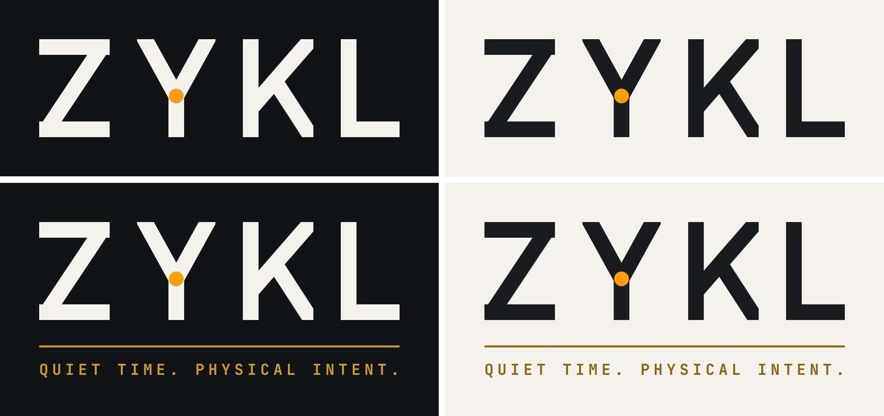
File | Dipakai untuk
ZYKL_Wordmark_OnDark / OnLight (.svg + .png transparan) | Header, end card video, watermark, navigasi website
ZYKL_Logo_PomodoroFocusTimer_OnDark / OnLight (.svg + .png transparan) | Logo utama, sama dengan judul toko: feature graphic Play, press kit, cover. Alternatif di folder yang sama: MonasticFocusInstrument (website, materi brand) dan Tagline_QuietTime (slide penutup post sosial)
ZYKL_Avatar_dark / light_1080 | Foto profil Instagram, Facebook, dan Threads (pakai yang dark)
Aturan pemakaian:
- Beri ruang kosong di setiap sisi minimal setinggi huruf Z.
- Ukuran minimum: wordmark 24 px tinggi, logo dengan slogan 48 px (di bawah itu slogan tidak terbaca).
- Warna tetap: Warm Bone #F4F2EC di latar gelap, Graphite #191B1F di latar terang, titik selalu Filament Amber #FF9E00. Jangan mewarnai hurufnya jadi amber.
- Jangan ditarik, diberi outline, diberi bayangan, atau ditaruh di atas foto yang ramai; pakai latar polos Obsidian atau Warm Bone.
- Slogan memakai JetBrains Mono Bold dan sudah diubah menjadi outline di file SVG, jadi file tetap aman walau font tidak terpasang.

Setelah minggu 4: apa yang diukur
Nilai empat minggu ini dari jumlah save, balasan, dan klik dari profil ke Play Store, bukan jumlah follower; akun baru tumbuh pelan, dan tiga angka itu yang menunjukkan apakah orang peduli.
Sinyal | Di mana melihatnya | Artinya | Kalau rendah
Save per post | Instagram Insights | Idenya layak disimpan | Perbanyak carousel seperti #3 dan #11, kurangi single image
Balasan per post Threads | Threads Insights | Obrolannya nyambung | Post lebih pendek, pertanyaan lebih tajam, lebih sering membalas orang lain
Klik link di bio | Insight profil Instagram | Minat berubah jadi aksi | Pindahkan link Play ke Story dengan link sticker
Pengunjung listing Play → install | Play Console, Store performance | Listing-nya meyakinkan | Uji set screenshot Warm Bone lebih dulu
Penonton bertahan 3 detik di Reel | Insight Reel | Frame pembukanya bekerja | Potong ulang 3 detik pertama dari adegan chaos
Mulai minggu 5, pertahankan ritmenya, naikkan post produk menjadi sekitar satu dari tiga, dan jadikan ide minggu 1 yang performanya terbaik sebagai seri bulanan.

